**Online company**

**System Requirements Document**

**Index**

1. **Introduction** ………………………………………………………………………………………………………………... 3
   1. **Objectives** ……………………………………………………………………………………………….…. 3
   2. **System Overview** ……………………………………………………………….………….……….…. 4
2. **User roles** ………………………………………………………………………………………………………………....... 5
3. **Functional Requirements** ……………………………………………………………………………………………. 6
4. **Workflow Charts** …………………………………………………………………………………………………………. 8
5. **Interface Design** ………………………………………………………………………………………………………… 10
6. **Rules** …………………………………………………………………………………………………………………….….… 11
7. **Project Programming Language and Technologies**…………………………………………………….. 11
8. **Project Upload Requirements**…………………………………………………………………………….….….. 11
9. **Project Evaluation**………………………...…………………………………………………………………….…….. 11
10. **Deadline**………………………...…………………………………………………………………….…………………… 12

**1. Introduction**

**1.1 Objectives**

This website aims to manage employee attendance and gain insight into employees through an employee management system, which do better plan and manage working hours, manage vacations, and tasks.

This document contains the following sections:

* User roles.
* Workflow diagrams.
* Functional requirements.

**1.2 System Overview**

The system is an integrated program developed to provide information on employees and manage working hours. It is a dynamic and responsive system. This provides an easy way to create a work center system to know more about the employees and their attendance and assign tasks to them.

The system consists of the following main parts:

* Check in to the system.
* Manage employees, managers, and departments.
* Additional services
* Reports and Statistics.

**2. User Roles**

**2.1.** **HR**

Is a user who follows the site and knows the employee’s working hours, and vacation days for each employee and transfers their salary.

**2.2. Manager**

Is a user who receives the leave request from the employee and reviews it and accepts or rejects this request, and is responsible for the specific department which consists of multiple employees.

**2.3. Employee**

It is the user who is responsible for solving tasks that are assigned to them and requests to leave and determines its type.

**3. Functional Requirements**

**3.1. manager:**

* Login to the system.
* See details about the department that is managed by him.
* See the department employee leaves and accept or reject them.
* Upload a task for each employee as pdf/word.
* Check their solution for the task, accept or reject it and give them feedback about it.
* Update his profile.

**3.2. Employee:**

* Login to the system.
* Record attendance.
* Take a leave and select its type.
* Receipt of an email from the manager with the status of leave.
* Search between two dates between leaves periods.
* Receive an email when the salary is transferred from HR.
* Updates his profile.
* Solve tasks and submit the solution.

**3.5. HR:**

* Register employees to the system.
* Obtains monthly and annual reports of employee salary (PDF or Excel).
* Transfer salary for all employees.
* Manage leave types.
* See all employees’ and managers’ leaves.
* Manage all department, their employees, and the managers for them.
* Manage home pages (home, contact us, about us, Testimonial).

**4.** **Workflow Chart**

**Footer**

**Contact Form**

**Nav bar**

**Header**

**Background / Slider**

**The Importance of Charity**

**4.2. Use Case Diagram**

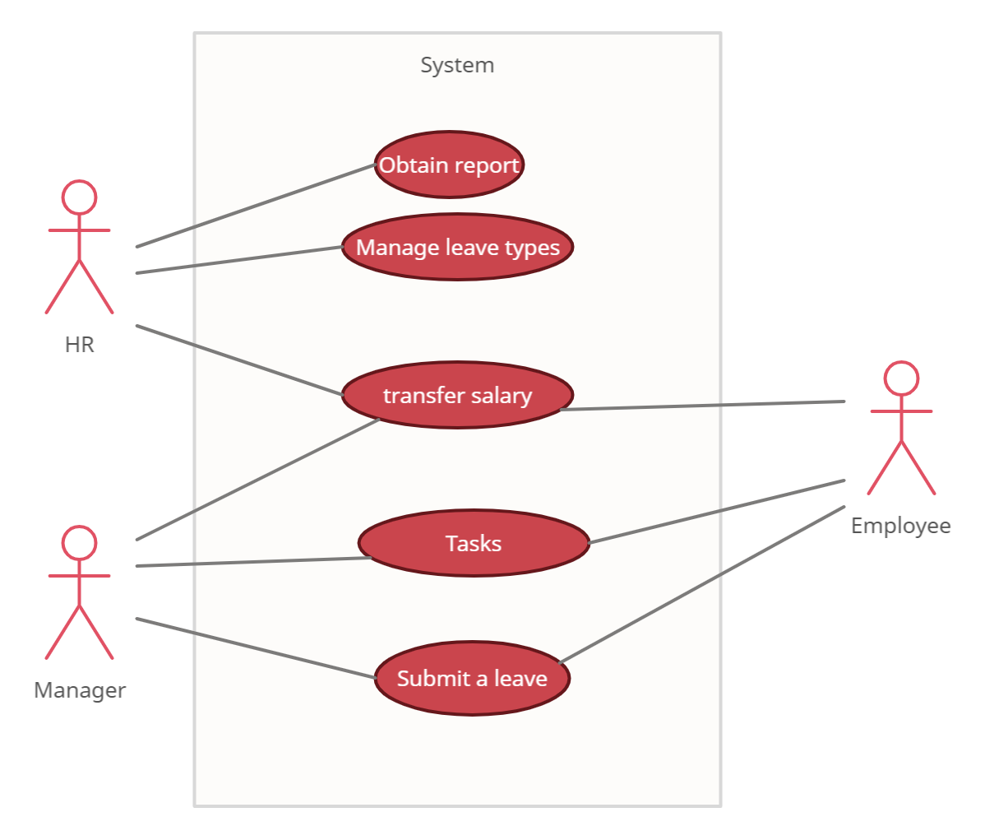

**4.3. Project Plan**

**5. Interface Design**

* Use the Bootstrap template to prepare the home page.
* Use the recognized colors in the design, such as blue and brown in different degrees.
* Don’t forget Search by, SSN and interval.
* The report displays on the website and document.
* The report must be containing charts.
* Use a dashboard template for different users.
* Users’ session must be designed.
* Home Page must contain reviews, testimonials, about us, contact us, header, footer and background or slider.
* Each part in the home must change dynamically using Database.

**6. Rules**

* Keep the rules of the clean code.
* Keep the rules of the business.
* Don't forget to design the logout button.
* Keep the project name.

**7.** **Project Programming Language and Technologies**

* Use Visual Studio 2019.
* Use SQL Developer.
* Use C# Programming Language.
* Use ASP.NET Core WAPI.
* Use Oracle.

**8. Project Upload Requirements**

* Upload your project code.
* Upload Project Presentation (Advertising presentation (.
* Upload Project Video.

**9. Project Evaluation**

15% Project video and presentation.

35% Interfaces Design.

50% Code Functionality.

**10. Deadline**

**07/02/2023 – 25/03/2023**

The project is submitted on the portal: 25/03/2023.

Toasters ---done

Download the task file ---done

Show the names of who arrived the task ---done

Add feedback when I reject or accept solution ---done

Edit task

Delete task